Robotics Process Automation Design and Development (UiPath) – BCG701 Lab
Experiment No: 5
Title: Develop UI automation in UiPath StudioX to demonstrate the following activities: Get Active Window, Maximize Window, Minimize Window, Hide Window, Restore Window and Move Window.

Aim: To develop a UI automation in UiPath StudioX that demonstrates controlling application windows using activities such as:
- Get Active Window
- Maximize Window
- Minimize Window
- Hide Window
- Restore Window
- Move Window

Theory:
- Get Active Window: Captures the currently active (foreground) application window, allowing subsequent operations to be applied to it.
- Maximize Window: Expands the application window to full screen.
- Minimize Window: Reduces the application window to the taskbar while keeping it open.
- Hide Window: Temporarily hides the window from view without closing it.
- Restore Window: Returns the window to its original state (normal size) after being maximized, minimized, or hidden.
- Move Window: Changes the position of the window on the screen by specifying X and Y coordinates.

Conduction:
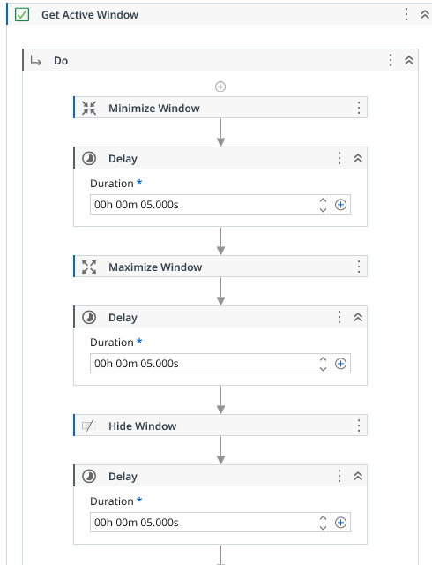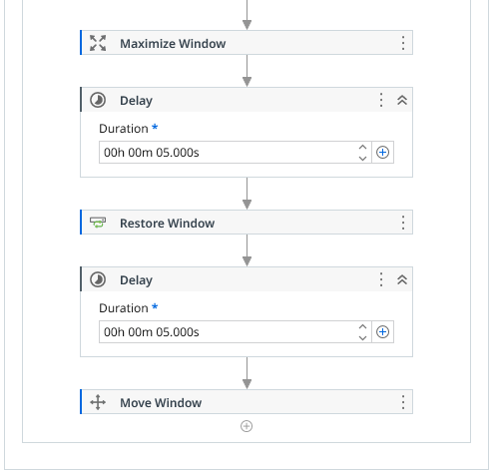
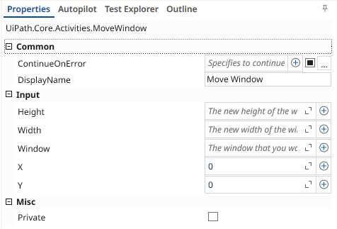
Output:
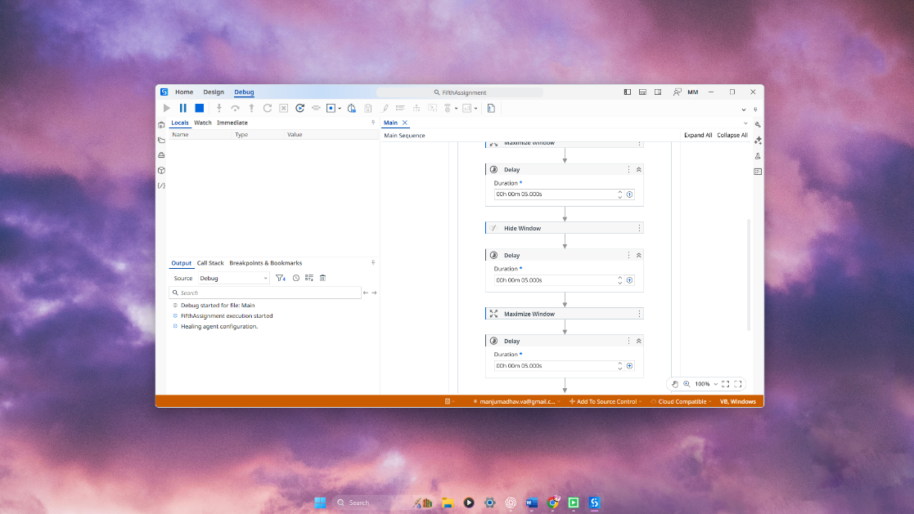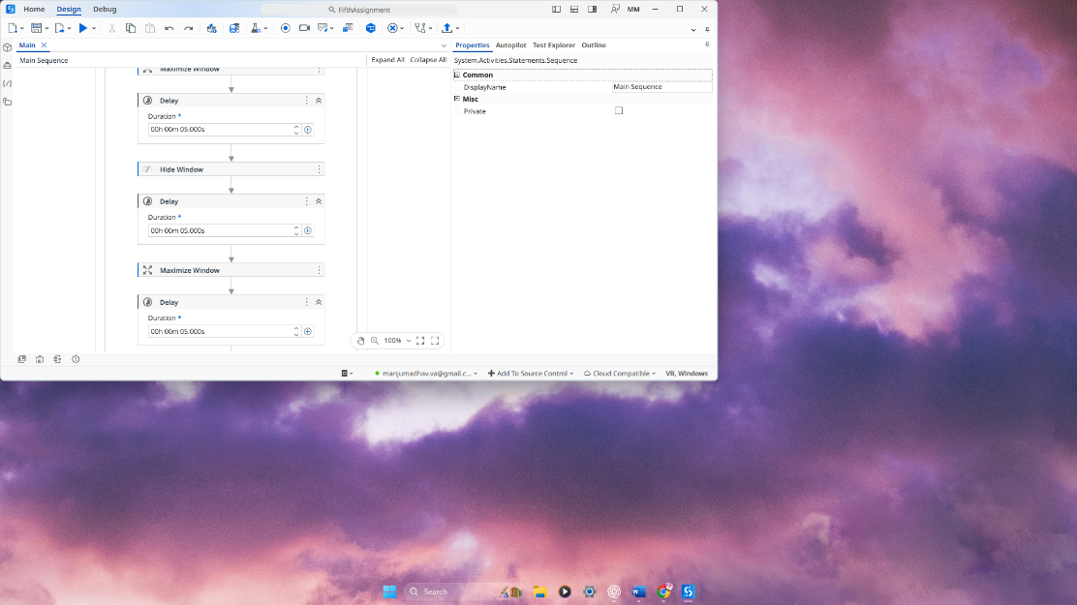
Observation and Results:
The following activities were successfully demonstrated in UiPath StudioX:
- Get Active Window
- Maximize Window
- Minimize Window
- Hide Window
- Restore Window
- Move Window
The output for the above-mentioned activities is verified.

Evaluation:
Evaluation Parameters | Maximum Marks | Obtained Marks
Conduction | 8
Record Writing | 4
Viva | 3
Total | 15

Signature of the Faculty in-charge with date:

